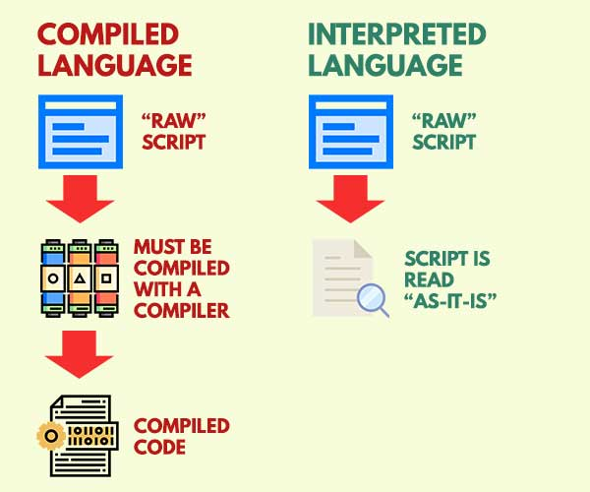

# Every program is a set of instructions, whether it’s to add two numbers or send a request over the internet. Compilers and interpreters take human-readable code and convert it to computer-readable machine code.

In a compiled language, the target machine directly translates the program. In an interpreted language, the source code is not directly translated by the target machine. Instead, a *different* program, aka the interpreter, reads and executes the code.

### **Okay… but what does that *actually* mean?**

Imagine you have a hummus recipe that you want to make, but it's written in ancient Greek. There are two ways you, a non-ancient-Greek speaker, could follow its directions.

The first is if someone had already translated it into English for you. You (and anyone else who can speak English) could read the English version of the recipe and make hummus. Think of this translated recipe as the *compiled* version.

The second way is if you have a friend who knows ancient Greek. When you're ready to make hummus, your friend sits next to you and translates the recipe into English as you go, line by line. In this case, your friend is the interpreter for the *interpreted* version of the recipe.

### **Compiled Languages**

Compiled languages are converted directly into machine code that the processor can execute. As a result, they tend to be faster and more efficient to execute than interpreted languages. They also give the developer more control over hardware aspects, like memory management and CPU usage.

Compiled languages need a “build” step – they need to be manually compiled first. You need to “rebuild” the program every time you need to make a change. In our hummus example, the entire translation is written before it gets to you. If the original author decides that he wants to use a different kind of olive oil, the entire recipe would need to be translated again and resent to you.

Examples of pure compiled languages are C, C++, Erlang, Haskell, Rust, and Go.

### **Interpreted Languages**

Interpreters run through a program line by line and execute each command. Here, if the author decides he wants to use a different kind of olive oil, he could scratch the old one out and add the new one. Your translator friend can then convey that change to you as it happens.

Interpreted languages were once significantly slower than compiled languages. But, with the development of [just-in-time compilation](https://guide.freecodecamp.org/computer-science/just-in-time-compilation), that gap is shrinking.

Examples of common interpreted languages are PHP, Ruby, Python, and JavaScript.

## **Advantages and disadvantages**

### **Advantages of compiled languages**

Programs that are compiled into native machine code tend to be faster than interpreted code. This is because the process of translating code at run time adds to the overhead, and can cause the program to be slower overall.

### **Disadvantages of compiled languages**

The most notable disadvantages are:

* Additional time needed to complete the entire compilation step before testing
* Platform dependence of the generated binary code

### **Advantages of interpreted languages**

Interpreted languages tend to be more flexible, and often offer features like dynamic typing and smaller program size. Also, because interpreters execute the source program code themselves, the code itself is platform independent.

### **Disadvantages of interpreted languages**

The most notable disadvantage is typical execution speed compared to compiled languages.